**LAB 2: Flow Visualisation**

Ratthamnoon Prakitpong - 63205165

Hamayun Aziz - 62064167

Arjun Vadehra - 20037164

Section A

Lab Date: February 9th, 2018

**Summary**

The purpose of this experiment was to demonstrate laminar and turbulent flow of air. This was done in two parts. In part 1, the laminar and turbulent flows were demonstrated as a stream of air passing over a streamlined body with yarns attached to it. Part 2 used a shadowgraph to see the flow of hot air as it passes around a cylinder. It was concluded that air does in fact stay laminar up until a certain point on a body and then moves on to become turbulent.

**Procedure**

See MECH 222 Lab Manual

**Results**

*Note: For all the figures, turbulent flow will be annotated with red arrows, while laminar flow will be annotated with blue arrows.*

**Airfoil**

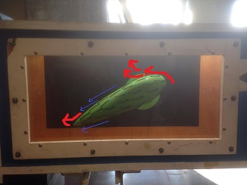

*Figure 1: Airfoil at a positive angle*

**From Figure 1**, the following observations were made. The yarns on the bottom of the airfoil are streamlined showing laminar flow for the majority of the bottom surface as the air flow is attached. Flow separation only happens near the ending tip of the airfoil. The top surface shows flow separation happening near the attacking edge and then the rest of the yarn on the body exhibit turbulent flow.

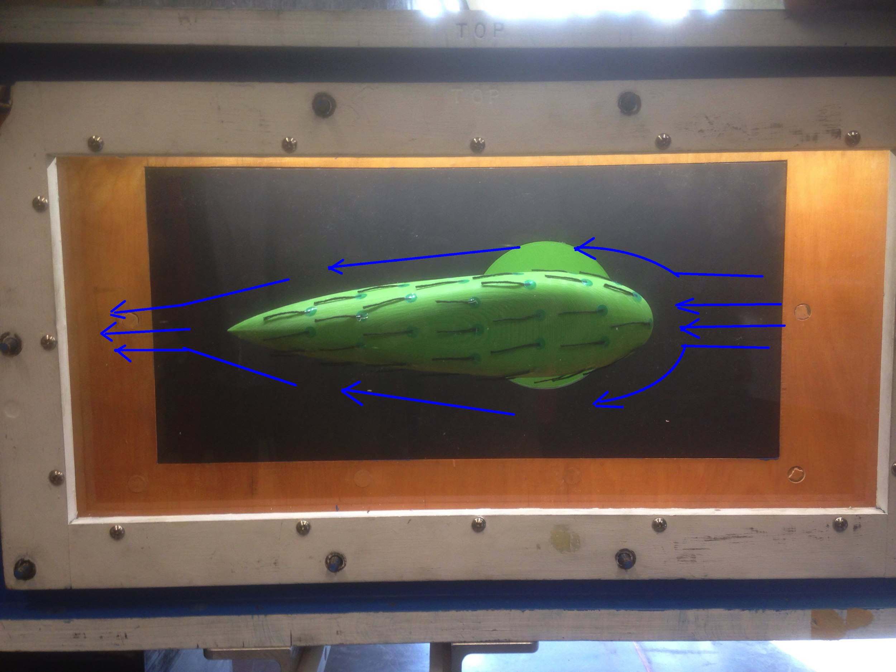

*Figure 2: Airfoil at 0 degree angle*

**From Figure 2**, the following observations were made. Both the top and bottom edge experience the same air flow. The attacking edge tip is where the stagnation point is. The yarns exhibit laminar airflow for ⅓ of the airfoil. Then towards the ending tip, flow separation occurs and the yarn starts fluttering showing turbulent flow. These observations match expectations

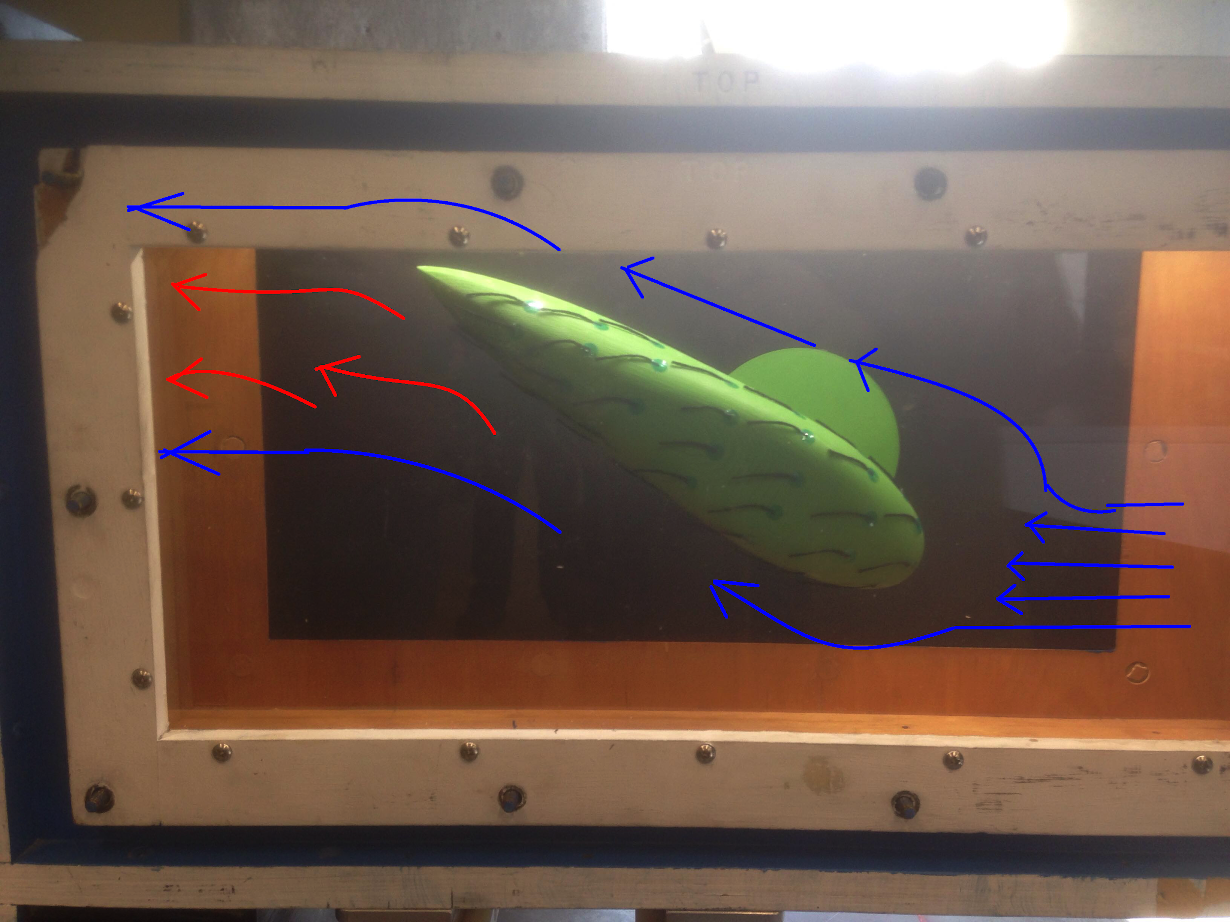

*Figure 3: Airfoil at negative angle*

**From Figure 3,** the following observations were made. The yarns on the top of the airfoil are streamlined showing laminar flow for the majority of the top surface. Flow separation only happens near the ending tip of the airfoil. The bottom surface shows flow separation happening near the attacking edge and then the rest of the yarn on the body exhibit turbulent flow.

**Shadowgraph**

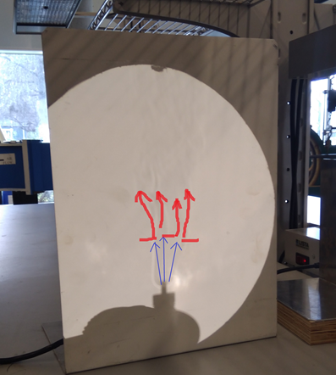

*Figure 4: Shadowgraph of candle*

The following observations were made from **Figure 4**. As the candle generates hot air, it rises in straight column and is attached; a laminar flow. After a certain distance , the flow separation takes place and the flow becomes turbulent. This can be seen in Figure 4, where the flow can be seen to be curling and travelling in different directions.

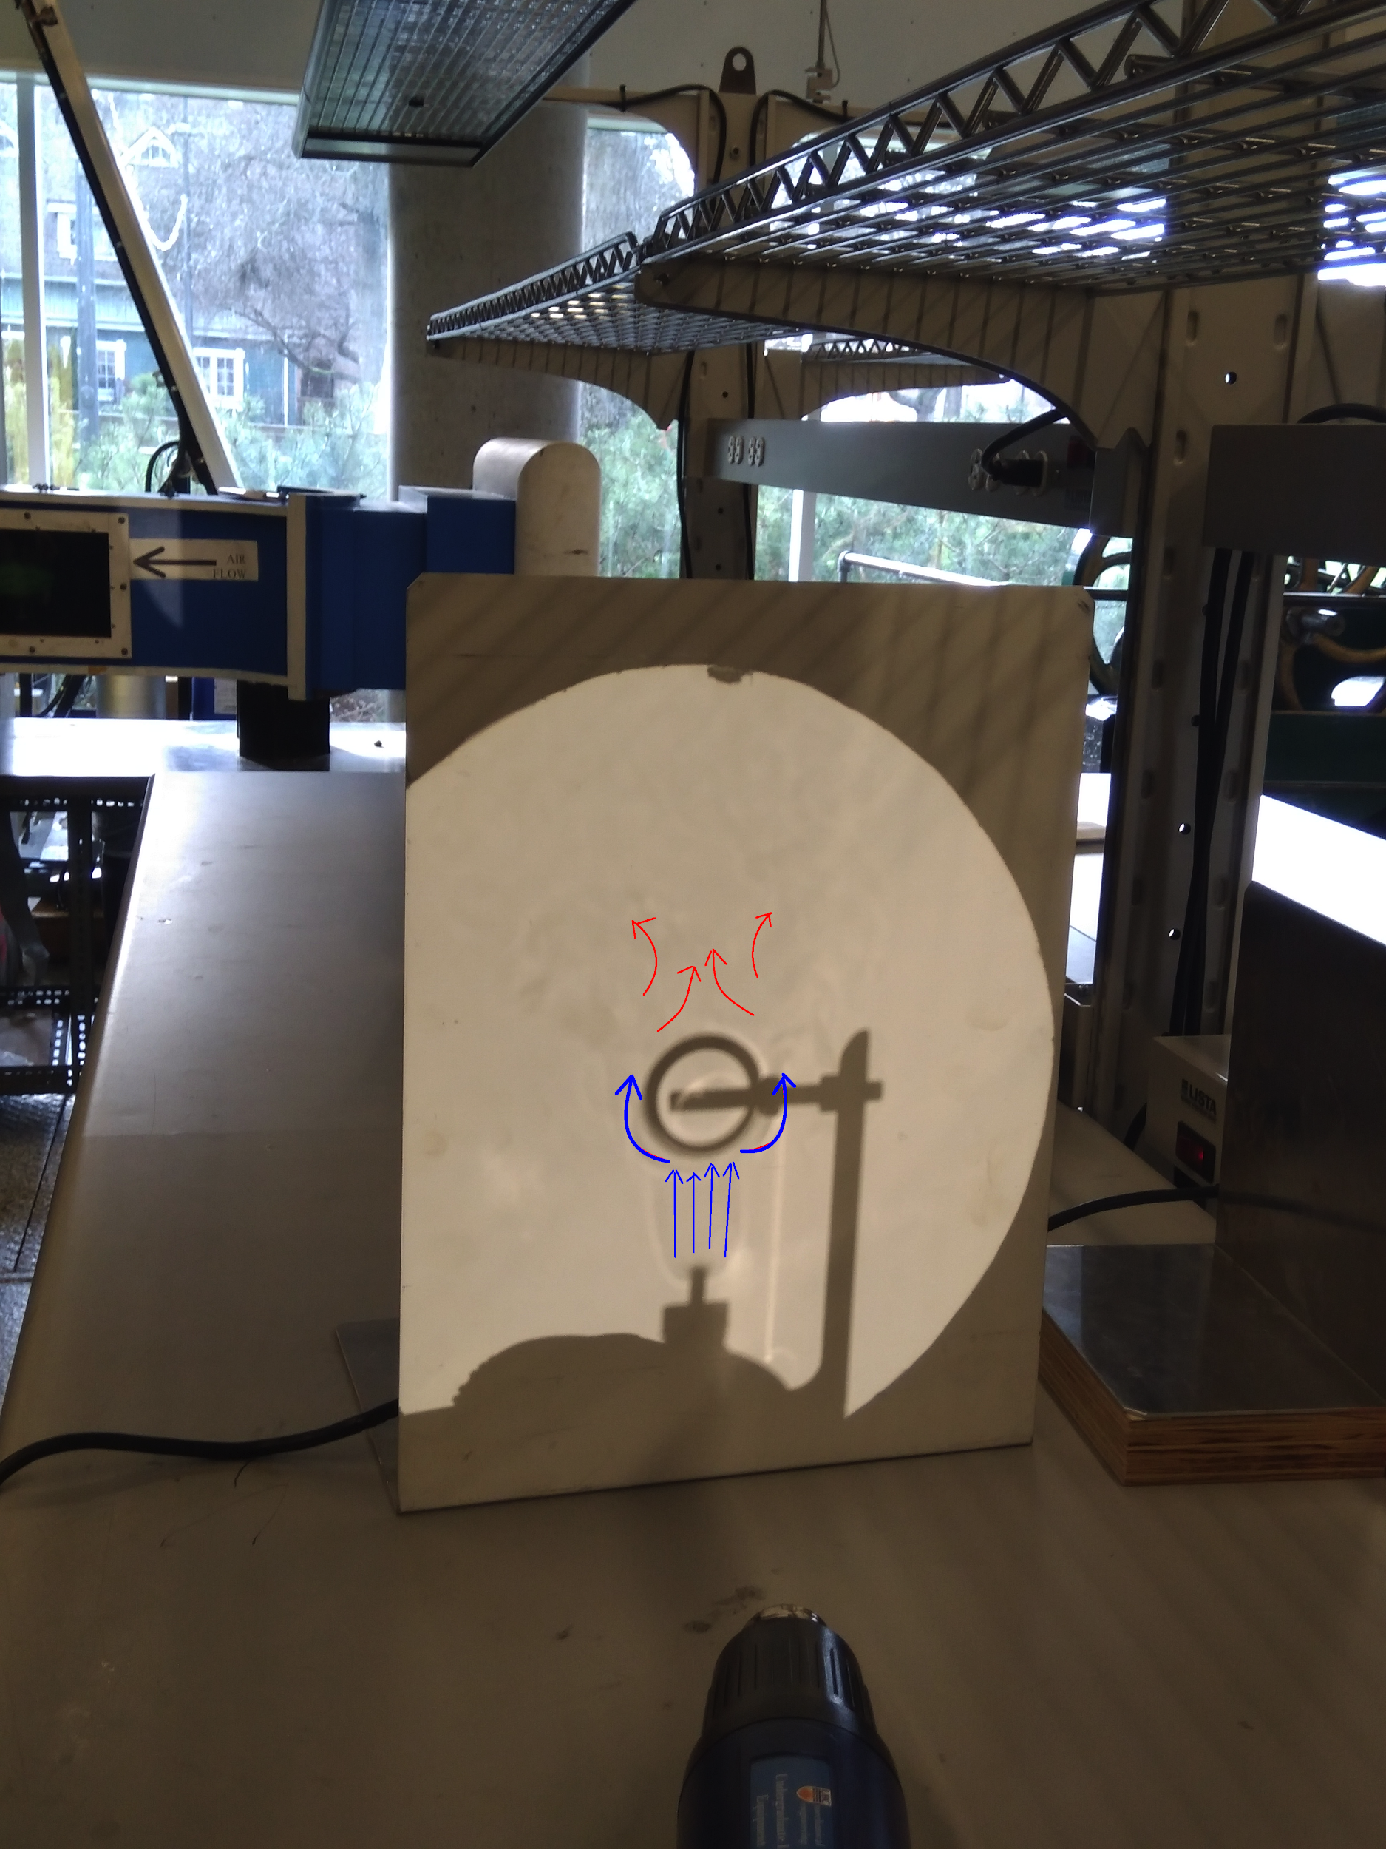

*Figure 5: Shadowgraph of candle under the tube*

The following observations were made from **Figure 5**. The flow is attached and laminar as it hot air right above the candle. The flow becomes attached to the tube at the sides and bottom and is still laminar. The flow remains attached for a certain distance on top of the tube. It then becomes separated and becomes turbulent flow.

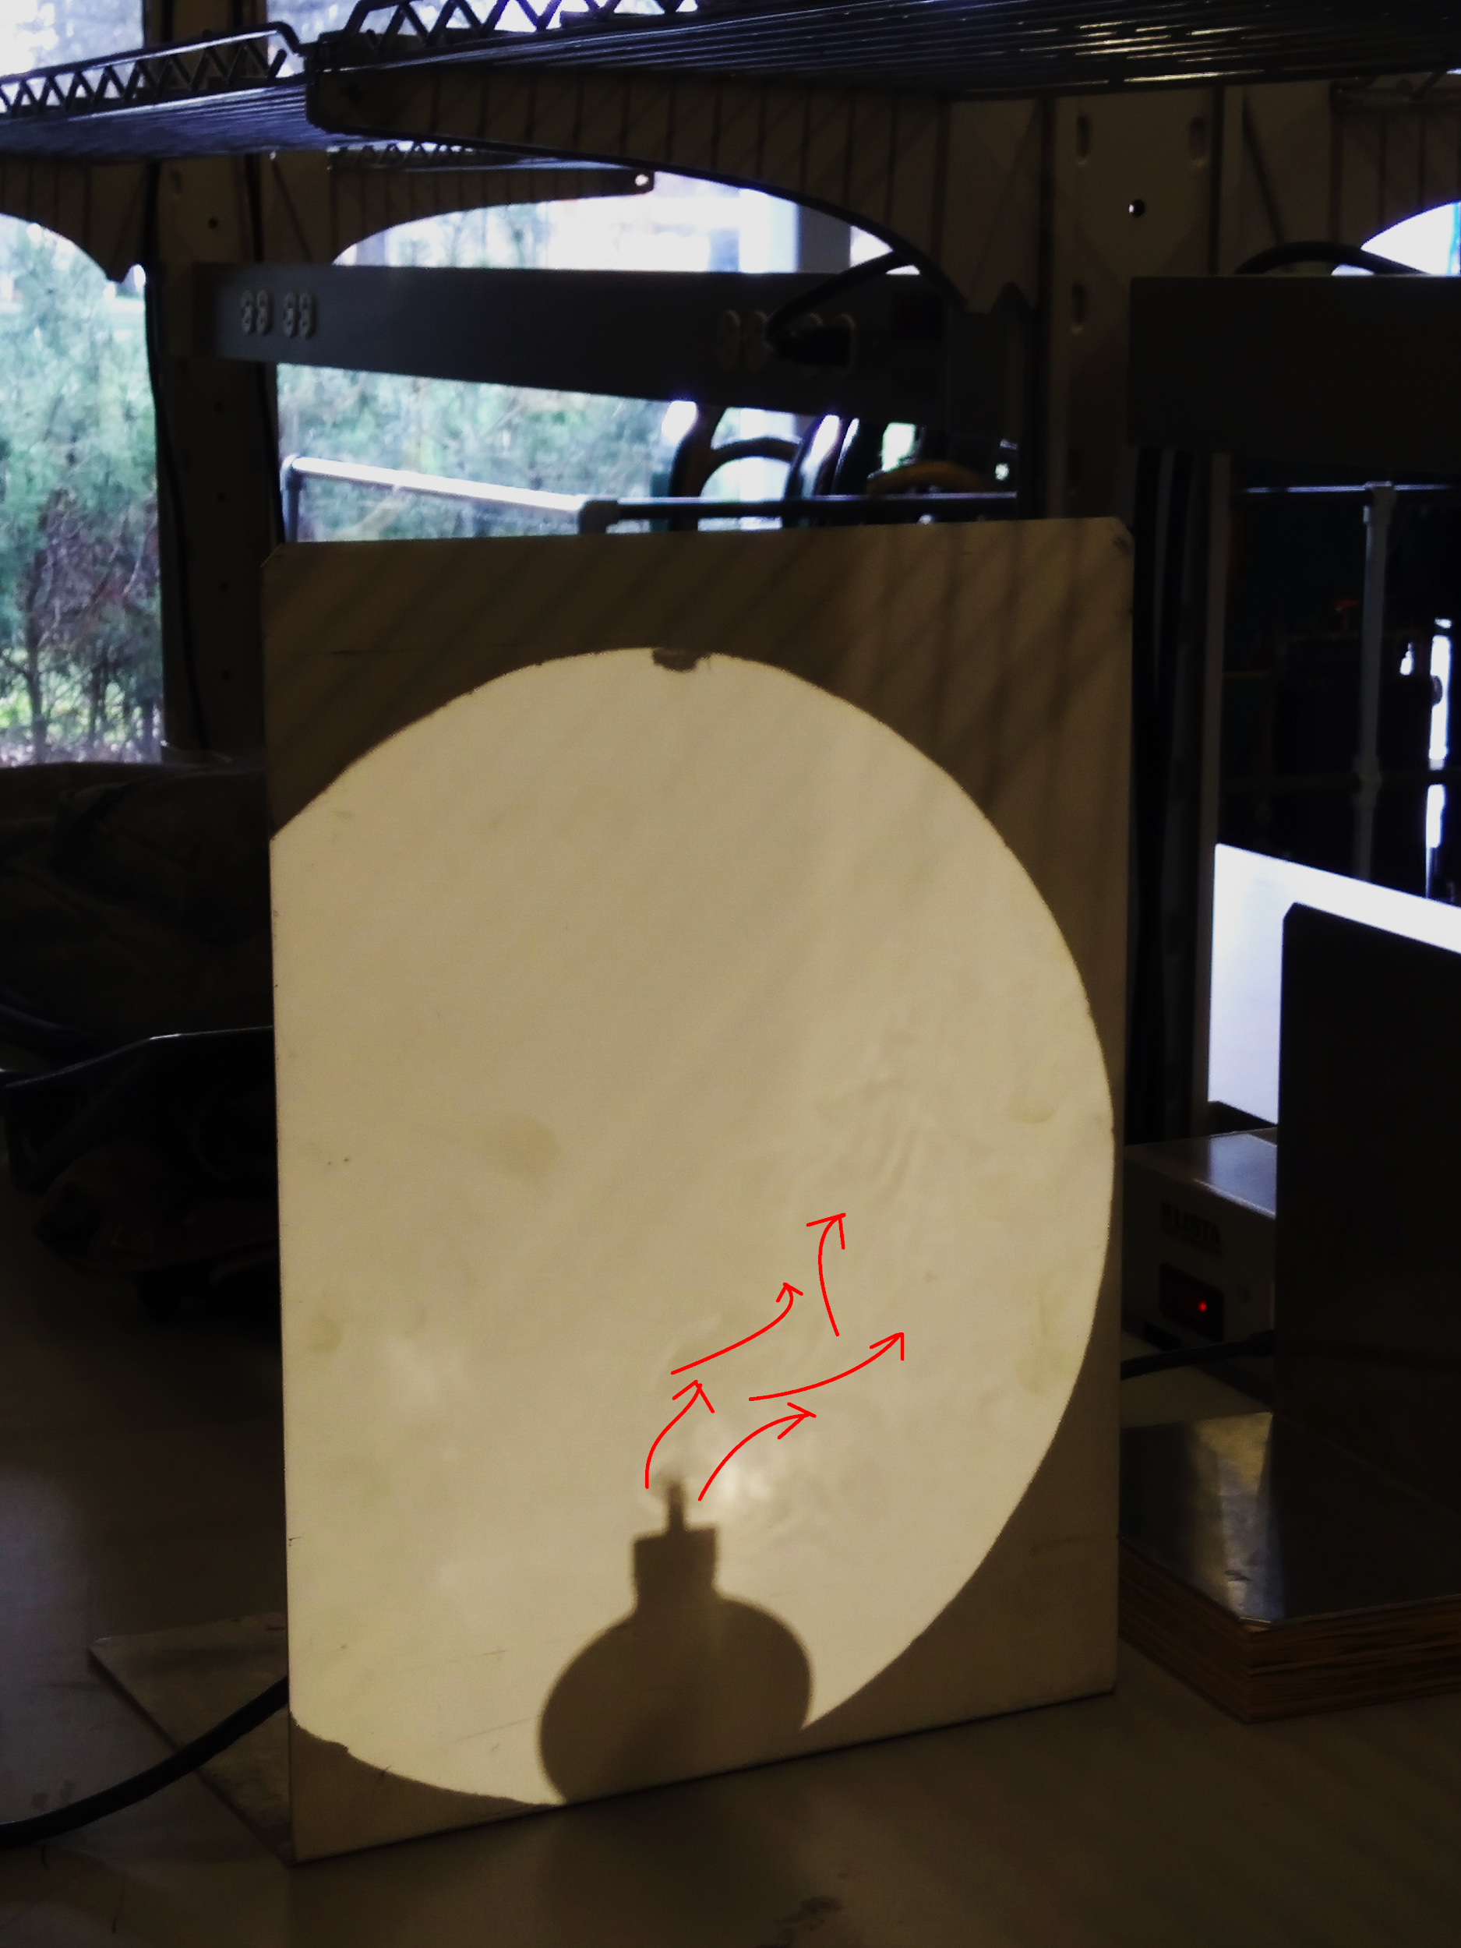

*Figure 5: Shadowgraph of candle under a small wind*

Since the small wind blew from the flow source, the flow separated as soon as it started. As the flow followed the direction of the wind from the blower, its turbulence and separation increased.

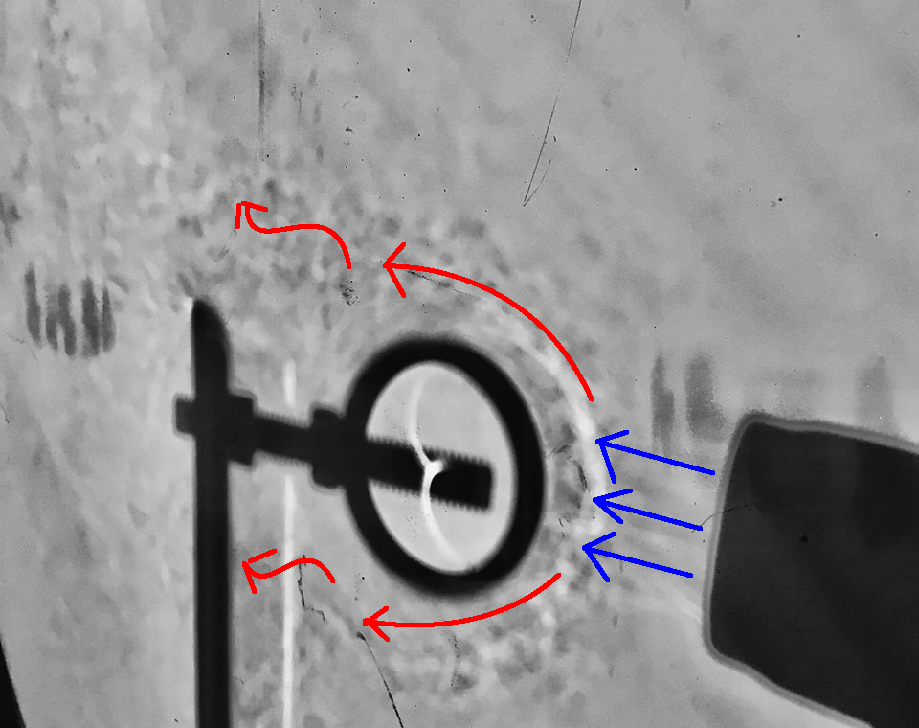

*Figure 6: Shadowgraph of heat gun directed horizontally at the tube*

The following observations were made from **Figure 6**. When the hot air leaves the heat gun, it is straight and follows a laminar flow. It then hits the tube and becomes attached to the tube. However, as the flow reaches the sides halfway diameter of the tube, it becomes separated and becomes a turbulent flow.

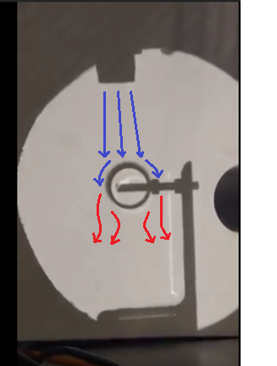

*Figure 7: Shadowgraph of heat gun directed downwards at the tube*

The following observations were made from **Figure 7**. When the hot air leaves the heat gun, it is straight and follows a laminar flow. It then hits the tube and becomes attached to the tub. However, as the flow reaches the sides halfway diameter of the tube, it becomes separated and becomes a turbulent flow.

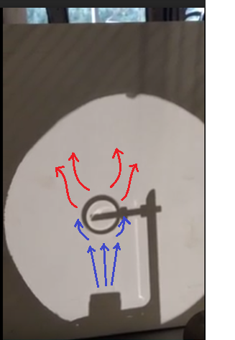

*Figure 8: Shadowgraph of heat gun directed upwards.*

When the hot air leaves the heat gun, it is straight and follows a laminar flow. It then hits the tube and becomes attached to the tub. However, as the flow reaches the sides halfway diameter of the tube, it becomes separated and becomes a turbulent flow.

**References**

Figure 6 was taken from Team A4 since our image for the process was not clear enough to show the relevant details.